Document A: Comparing Cartoon to Picture
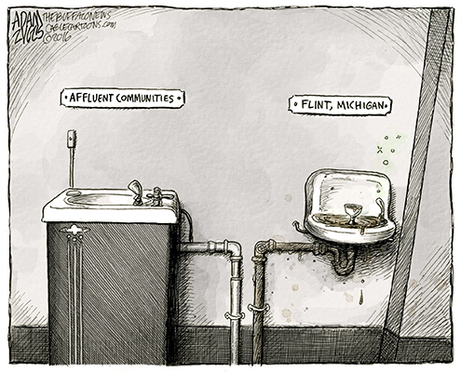
Source: blogs.denverpost.com
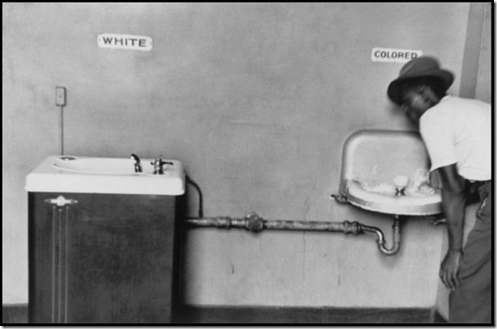
Source: Google images
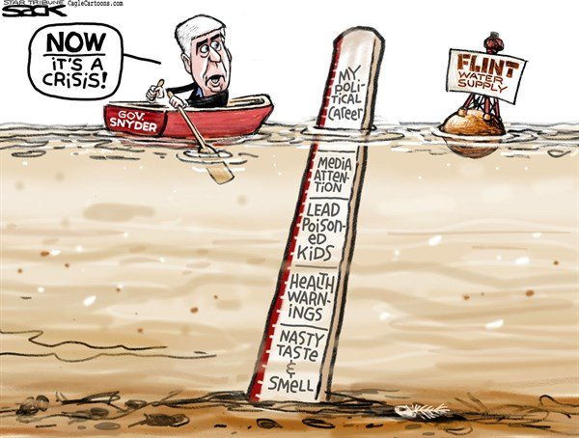
Document B: Two Political Cartoons, Flint Michigan
Source: www.pennlive.com

Source: www.politicususa.com
Document C: How Lead Affects Children’s Health
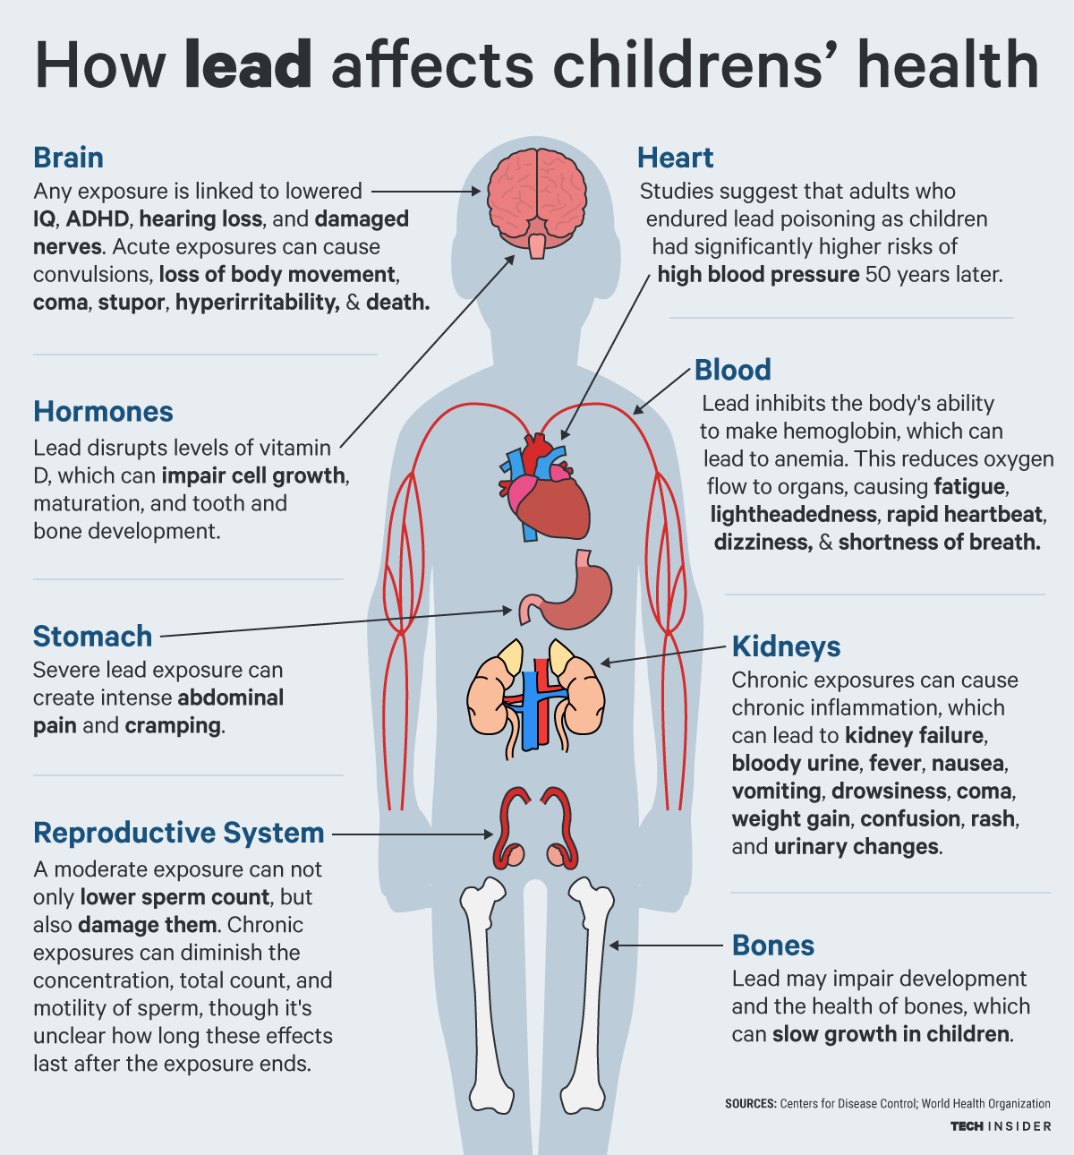

Source: http://www.techinsider.io/lead-health-child-flint-michigan-body-pollution-water-2016-1

Document D: Polls about Rick Snyder’s Job Performance
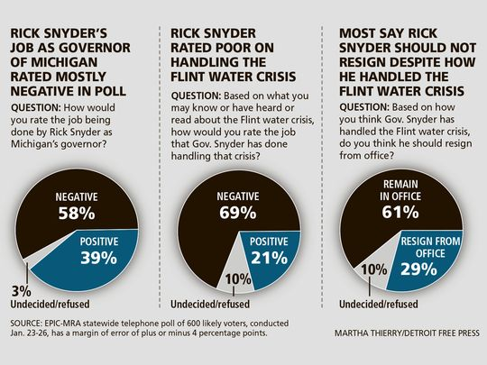
Source: http://www.freep.com

Document E: Flint’s Toxic Water Pricing
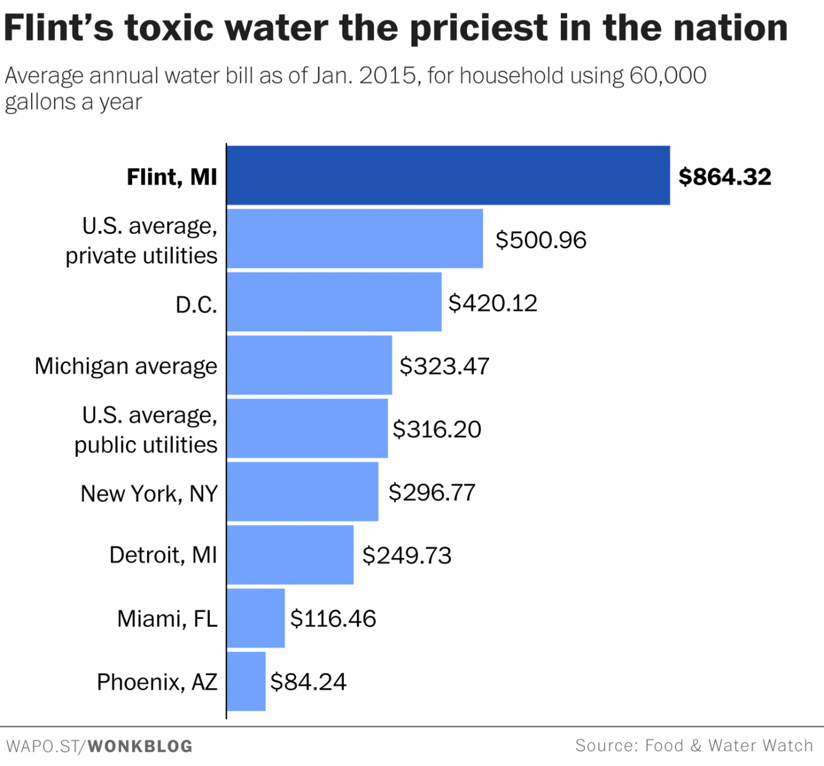
Flint employment information
Index | Flint | Michigan
Income per capita | $14,606 | $25,547
Median household income | $26,339 | $48,471
Median income owner occupied | $37,269 | $59,341
Median income renter occupied | $14,601 | $25,409
The median household income across New York City stands at $50,711, according to 2010-2012 estimates from the U.S. Census Bureau

Document F:
How Flint traded safe drinking water for cost-cutting plan that didn't work
The decision to switch the city of Flint’s drinking water source to the Flint River was pegged as a cost-cutting maneuver aimed at saving $5m over a two-year period. But almost two years and a massive lead contamination crisis later, that move and subsequent decisions not to treat the water supply already carry a financial price tag of $45m and climbing.
Since early October, when Michigan governor Rick Snyder first conceded that lead contamination in the Rust Belt community of 100,000 was far more serious than he initially understood, state and federal agencies have pledged at least $45m to address the ongoing crisis, including:
- In October, Snyder announced a $12m plan to transfer Flint back to the city of Detroit’s water system. The state covered half the cost, while Flint kicked in $2m and the Charles Stewart Mott Foundation contributed $4m.
- Last week, Barack Obama approved Snyder’s request to declare a federal emergency in Flint, providing $5m in financial assistance through the Federal Emergency Management Agency for additional water, water filters and water test kits.
- On Tuesday, during his state of the state address, Snyder promised a $28m aid package for the city of Flint that includes $17.2m for bottled water and filters; $3m for city utilities for loss of revenue; and nearly $4m for behavioral health care for children with elevated blood lead levels. The plan has since been approved by the Michigan house of representatives, and is pending in the state senate.
- At the US conference of mayors in Washington DC this week, Flint mayor Karen Weaver said the city “needs to be made a priority” by the state and federal government.
- “This is bigger than the city can handle financially … so we need some federal assistance,” Weaver said. What [Snyder] talked about is a very good start, but we deserve more resources, and more finances as a result of this.”
- For decades, the city relied on the Detroit water system to provide water. But in the face of financial calamity, in early 2014, a state-appointed emergency manager running the city green-lighted the switch to a local source.
- By last February, the costs to address water quality issues in the city started to accumulate. As tensions in Flint started to grow over the city’s water quality, the state government provided a $2m grant for “water system enhancements” in Flint.
http://www.theguardian.com/us-news/2016/jan/23/flint-water-crisis-cost-cutting-switch-water-supply

